Index.html.erb
<h1>S1519006 News Management System</h1>
<li style="font-size: larger">
<%= link_to 'Home', {:action => 'index'} %>
<%= link_to 'News', {:action => 'news'} %>
<%= link_to 'Admin', {:action => 'adminlog'} %>
</li><br>
<%= form_tag "search" do %>
<div>
<!-- Form to search for term in articles -->
<%= label_tag(:term, "Enter the search term") %>
<%= text_field_tag(:term, nil) %>
</div>
<%= submit_tag "Search" %>
<% end %>
<!-- Uses array of presorted hash to display the 4 most recently updated articles -->
<% count = 0 %>
<% @articlesSorted.each do |article| %>
<h2><u><%= article.title %></u></h2>
<!-- Cuts off the article body at 60 characters -->
<%= article.body.slice(0..60) %>
<a href="/articles/<%= article.id %>" style="background: lightgray">
READ MORE >>
<% count += 1 %>
</a>
<% break if count == 4 %>
<% end %>
News.html.erb
<h1>S1519006 News Management System</h1>
<li style="font-size: larger">
<%= link_to 'Home', {:action => 'index'} %>
<%= link_to 'News', {:action => 'news'} %>
<%= link_to 'Admin', {:action => 'adminlog'} %>
</li><br>
<!-- Displays all articles by genre -->
<% @genres.each do |genre| %>
<h2><u>Category: <%= genre.title %></u></h2>
<% @articles.each do |article| %>
<% if genre.id == article.genre_id %>
<h2><%= article.title %></h2>
<%= article.body.slice(0..60) %>
<a href="/articles/<%= article.id %>" style="background: lightgray">
READ MORE >>
</a>
<% end %>
<% end %>
<% end %>

Search.html.erb
<h1>Search results for "<%= params[:term] %>"</h1>
<li style="font-size: larger">
<%= link_to 'Home', {:action => 'index'} %>
<%= link_to 'News', {:action => 'news'} %>
<%= link_to 'Admin', {:action => 'adminlog'} %>
</li><br>
<!-- Displays all articles found in the array -->
<% @foundArticles.each do |article| %>
<h2><u><%= article.title %></u></h2>
<%= article.body.slice(0..60) %>
<a href="/articles/<%= article.id %>" style="background: lightgray">
READ MORE >>
</a>
<% end %>

Show.html.erb
<h1><%= @article.title %></h1>
<li style="font-size: larger">
<%= link_to 'Home', {:action => 'index'} %>
<%= link_to 'News', {:action => 'news'} %>
<%= link_to 'Admin', {:action => 'adminlog'} %>
</li><br>
<!-- Displays information relevant to the article -->
<strong>Genre: </strong><span><%= @genre.title %></span><br>
<strong>Source: </strong><span><%= @article.publisher %></span><br>
<strong>Last Updated: </strong><span><%= @article.updated_at.inspect %></span><br>
<strong>Body: </strong>
<p><%= @article.body %></p>
<!-- Displays all comments relevant to the article -->
<h2>Comments</h2>
<% @article.comments.each do |comment| %>
<P>
<strong><%= comment.commented %>: </strong><%= comment.body %>
</P>
<% end %>
<!-- Form to add a comment to the article -->
<h2>Add a comment:</h2>
<%= form_with model: [ @article, @article.comments.build ] do |form| %>
<p>
<%= form.label :commented %><br>
<%= form.text_field :commented %>
</p>
<p>
<%= form.label :body %><br>
<%= form.text_area :body %>
</p>
<p>
<%= form.submit %>
</p>
<% end %>
<%= link_to "Back", articles_path %>

Adminlog.html.erb
<h1>S1519006 News Management System</h1>
<li style="font-size: larger">
<%= link_to 'Home', {:action => 'index'} %>
<%= link_to 'News', {:action => 'news'} %>
<%= link_to 'Admin', {:action => 'adminlog'} %>
</li><br>
<!-- Login form -->
<%= form_tag "/login" do %>
<div>
<%= label_tag(:uname, "Username") %>
<%= text_field_tag(:uname, nil) %>
<%= label_tag(:pword, "Password") %>
<%= text_field_tag(:pword, nil) %>
</div>
<%= submit_tag "login" %>
<% end %>

Admin.html.erb
<h1>S1519006 News Management System - Admin Screen</h1>
<li style="font-size: larger">
<%= link_to 'Log Off', {:action => 'index'} %>
<%= link_to 'New Article', {:action => 'newA'} %>
<%= link_to 'New Category', {:action => 'newC'} %>
</li><br>
<!-- Admin main page, orders by genre items -->
<% @genres.each do |genre| %>
<h2><u>Category: <%= genre.title %> </u> <%= link_to "edit", {:action => 'editC', :id => genre.id}%> | <%= link_to "delete", {:action => 'removeC', :id => genre.id}%></h2>
<% @articles.each do |article| %>
<% if genre.id == article.genre_id %>
<h2><%= article.title %></h2>
<li>
<%= link_to "hide", {:action => 'hide', :id => article.id} %> |
<%= link_to "edit", {:action => 'editA', :id => article.id} %> |
<%= link_to "delete", {:action => 'removeA', :id => article.id, } %>
</li>
<%= article.body.slice(0..60) %>
<a href="/articles/<%= article.id %>" style="background: lightgray">
READ MORE >>
</a>
<% end %>
<% end %>
<% end %>
NewA.html.erb
<%= form_for @article do |article| %>
<!-- Form so user can enter items for new article -->
<p><%= article.label :title %> <%= article.text_field :title %>
<p><%= article.label :body %> <%= article.text_area :body %>
<p><%= article.label :genre_id %> <%= article.collection_select :genre_id, Genre.all, :id, :title %>
<p><%= article.label :publisher %> <%= article.text_field :publisher %>
<p><%= submit_tag "Create Article" %>
<% end %>
NewC.html.erb
<%= form_for @genre do |genre| %>
<!-- Form so user can enter items for new category -->
<p><%= genre.label :title %> <%= genre.text_field :title %>
<p><%= submit_tag "Create Category" %>
<% end %>
EditA.html.erb
<%= form_for @article do |article| %>
<!-- Form so user can enter items for edited article -->
<p><%= article.label :title %> <%= article.text_field :title %>
<p><%= article.label :body %> <%= article.text_area :body %>
<p><%= article.label :genre_id %> <%= article.collection_select :genre_id, Genre.all, :id, :title %>
<p><%= article.label :publisher %> <%= article.text_field :publisher %>
<p><%= submit_tag "Update Article" %>
<% end %>
EditC.html.erb
<%= form_for @genre do |genre| %>
<!-- Form so user can enter items for edited category -->
<p><%= genre.label :title %> <%= genre.text_field :title %>
<p><%= submit_tag "Update Category" %>
<% end %>

removeA.html.erb
<h2>Deleting Article</h2>
<%= form_for @article, method: :delete do %>
<!-- Form to display contents of article before deletion -->
<p>Title: <%= @article.title %></p>
<p>Body: <%= @article.body %></p>
<p>Genre: <%= @genre.title %></p>
<p>Publisher: <%= @article.publisher %></p>
<p><%= submit_tag "Delete Article", onclick: "return confirm('Are you sure?')" %>
<% end %>
removeC.html.erb
<h2>Deleting Category</h2>
<%= form_for @genre, method: :delete do %>
<!-- Form to display contents of category before deletion -->
<p>Title: <%= @genre.title %></p>
<p><%= submit_tag "Delete Category", onclick: "return confirm('Are you sure?')" %>
<% end %>

Articles_controller
class ArticlesController < ApplicationController
protect_from_forgery with: :null_session
# Index, uses .order to create an order of articles based on the time each article was last updated
def index
@articles = Article.all
@articlesSorted = Article.order(updated_at: :desc)
end
# Displays all information related to the article, uses .find to get the relevant genre title for the article
def show
@article = Article.find(params[:id])
@genre = Genre.find(@article.genre_id)
end
# Pulls all information related to all articles and genres for display
def news
@articles = Article.all
@genres = Genre.all
end
# Searches in all article titles and bodies to search for relevant content
def search
@articles = Article.all
if params[:term].to_s.length >0
@foundArticles = Array.new
# Creates an array to place all articles where it finds relevant content in
@articles.each do |article|
if article.body.downcase.include? params[:term].to_s.downcase
@foundArticles.push(article)
elsif article.title.downcase.include? params[:term].to_s.downcase
@foundArticles.push(article)
end
end
puts @foundArticles
end
end
# Admin login screen information
def adminlog
@users = User.all
end
# Admin login logic, tests entered details against information in the User table, if both match logs user in
def login
@users = User.all
@users.each do |user|
if params[:uname].to_s == user.uname && params[:pword].to_s == user.pword
redirect_to '/admin/'
end
end
end
# Admin main screen information
def admin
@articles = Article.all
@genres = Genre.all
end
def hide
@articles = Article.all
@genres = Genre.all
end
# Article parameters for updating
def article_params
params.inspect
params.require(:article).permit(:id, :title, :body, :created_at, :updated_at, :genre_id, :publisher)
end
# Information needed for editing article
def editA
@article = Article.find(params[:id])
@genres = Genre.all
@genre = Genre.find(@article.genre_id)
end
# Information needed for editing category
def editC
@genre = Genre.find(params[:id])
end
# Logic for updating articles
def update
@article = Article.find(params[:id])
@genres = Genre.all
@genre = Genre.find(@article.genre_id)
if @article.update(article_params)
redirect_to "/admin"
else
render :action => 'editA'
end
end
# Information needed for creating articles
def newA
@article = Article.new
@genres = Genre.all
end
# Information needed for creating categories
def newC
@genre = Genre.new
end
# Logic for creating articles
def create
@article = Article.new(article_params)
@genres = Genre.all
if @article.save
redirect_to "/admin"
else
render :action => 'newA'
end
end
# Information needed to delete articles
def removeA
@article = Article.find(params[:id])
@genres = Genre.all
@genre = Genre.find(@article.genre_id)
end
# Information needed to delete categories
def removeC
@genre = Genre.find(params[:id])
@articles_filtered = Array.new
@articles_filtered = Article.find(@genre.id)
end
# Logic needed to delete articles
def destroy
@article = Article.find(params[:id])
@genre = Genre.find(@article.genre_id)
if @article.destroy
redirect_to "/admin"
end
end
end
Comments_controller
class CommentsController < ApplicationController
# Information needed to create comments
def create
@article = Article.find(params[:article_id])
@comment = @article.comments.create(comment_params)
redirect_to article_path(@article)
end
# Information for comments to save
private
def comment_params
params.require(:comment).permit(:commented, :body)
end
end
Genres_controller
class GenresController < ApplicationController
protect_from_forgery with: :null_session
# Logic for updating categories
def update
@genres = Genre.all
@genre = Genre.find(params[:id])
if @genre.update(genre_params)
redirect_to "/admin"
else
render :action => 'articles/editC'
end
end
# Logic for creating categories
def create
@genre = Genre.new(genre_params)
if @genre.save
redirect_to "/admin"
else
render :action => 'articles/newC'
end
end
# Logic for deleting categories
def destroy
@genre = Genre.find(params[:id])
@articles_filtered = Array.new
@articles_filtered = Article.find(@genre.id)
if @genre.destroy
redirect_to "/admin"
end
end
# Category parameters for updating
def genre_params
params.inspect
params.require(:genre).permit(:id, :title, :created_at, :updated_at)
end
end

article.rb
class Article < ApplicationRecord
has_many :comments, dependent: :delete_all
belongs_to :genre
validates :title, :presence => true
validates :body, :presence => true
end
comment.rb
class Comment < ApplicationRecord
belongs_to :article
end
genre.rb
class Genre < ApplicationRecord
has_many :articles, dependent: :delete_all
end
user.rb
class User < ApplicationRecord
end

Index page
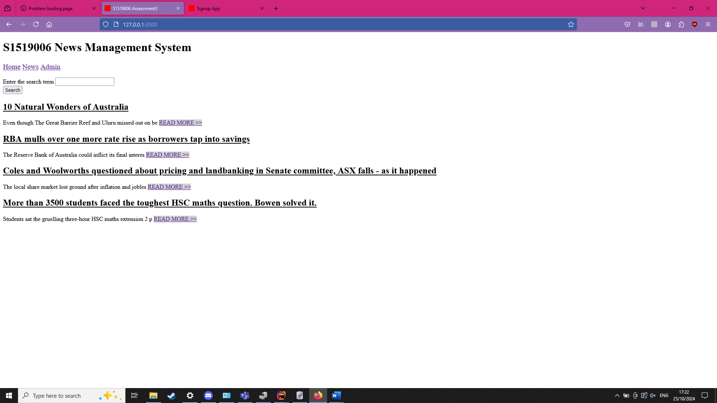
Show article
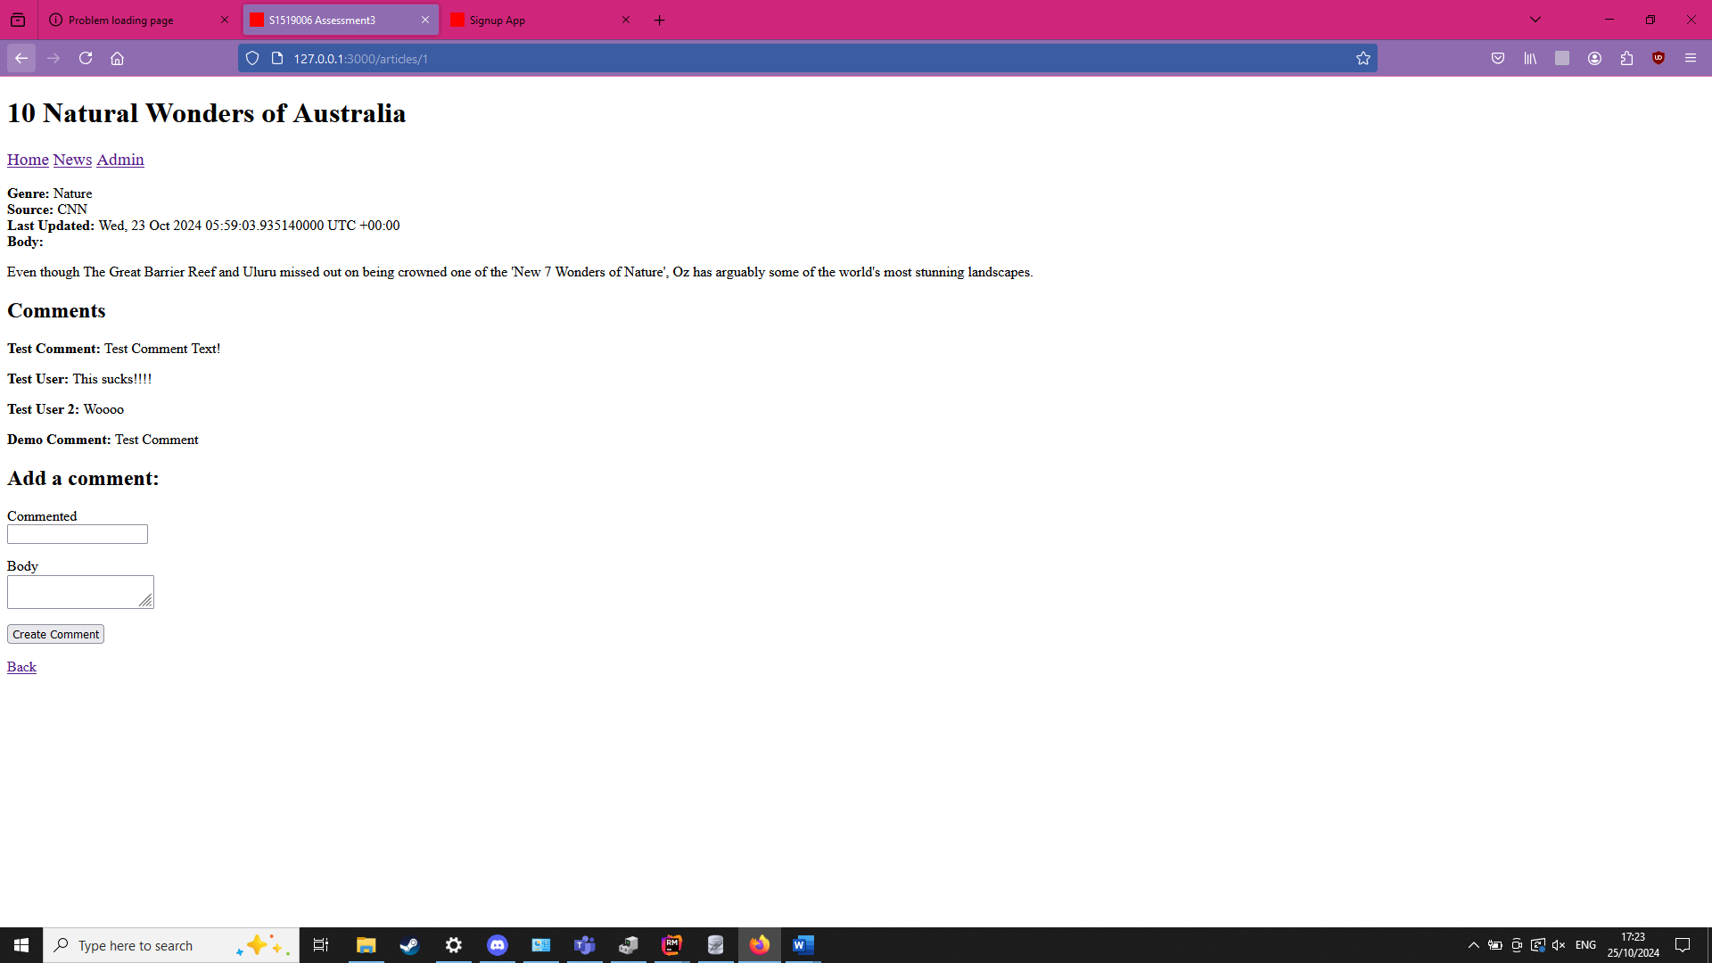

Search
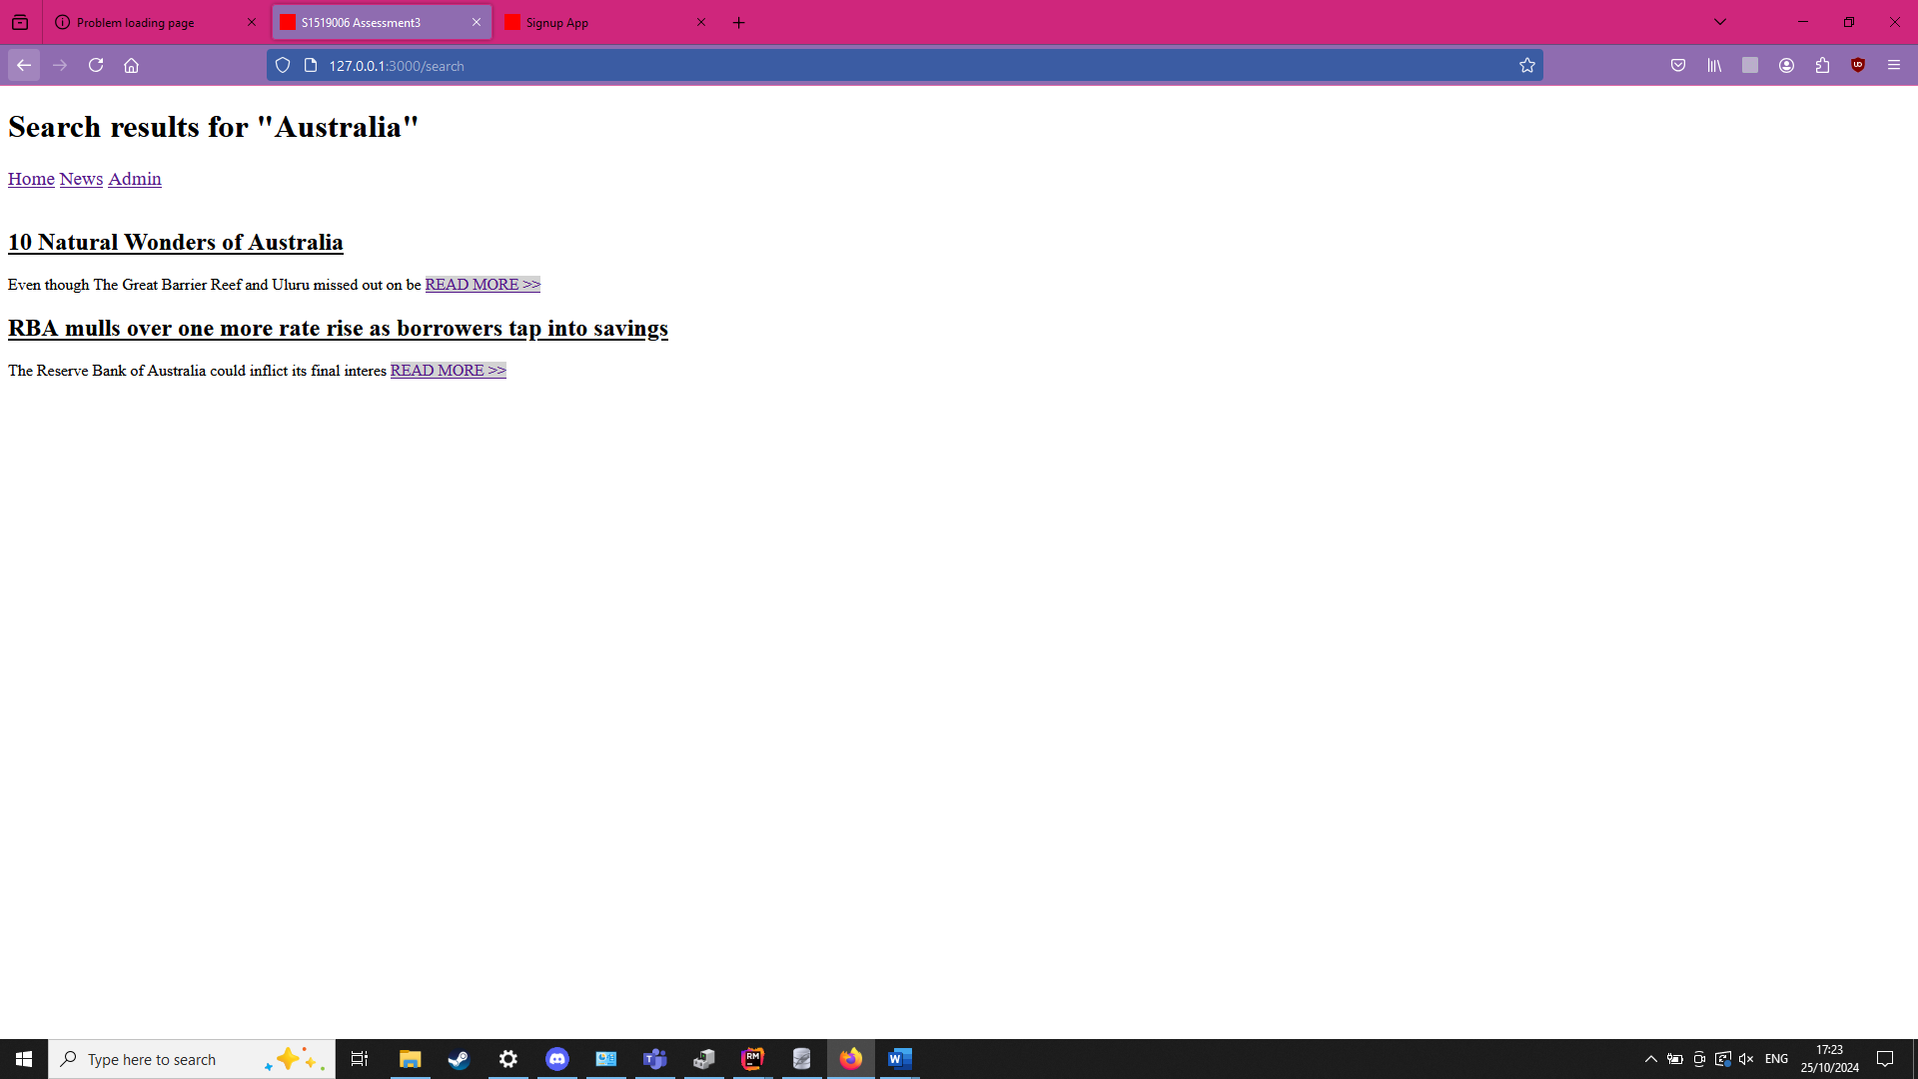
All articles page
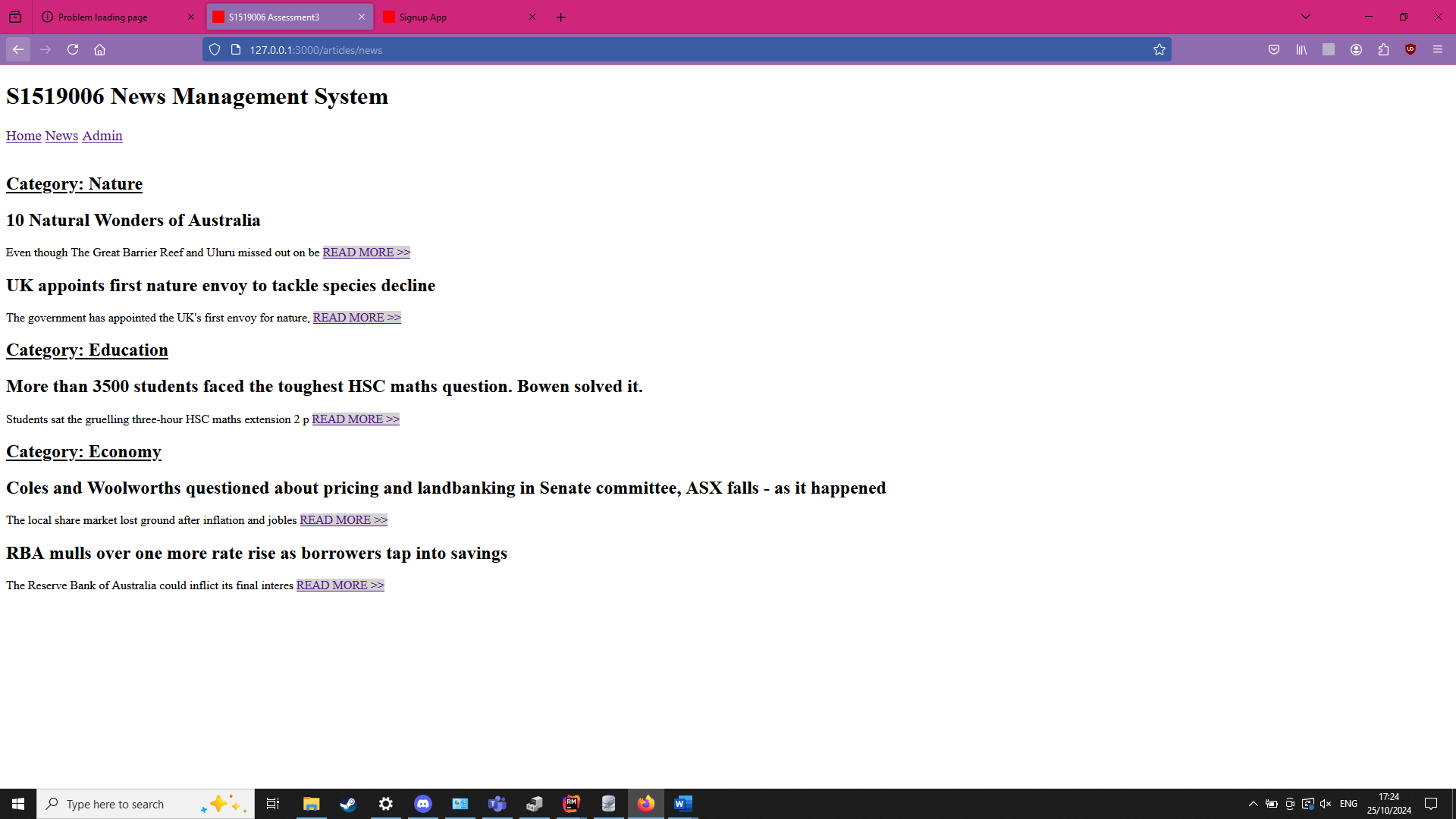

Admin login
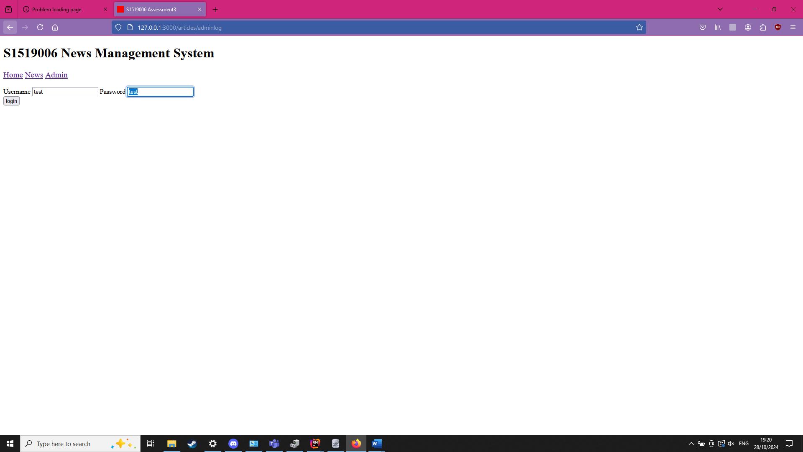
Admin screen
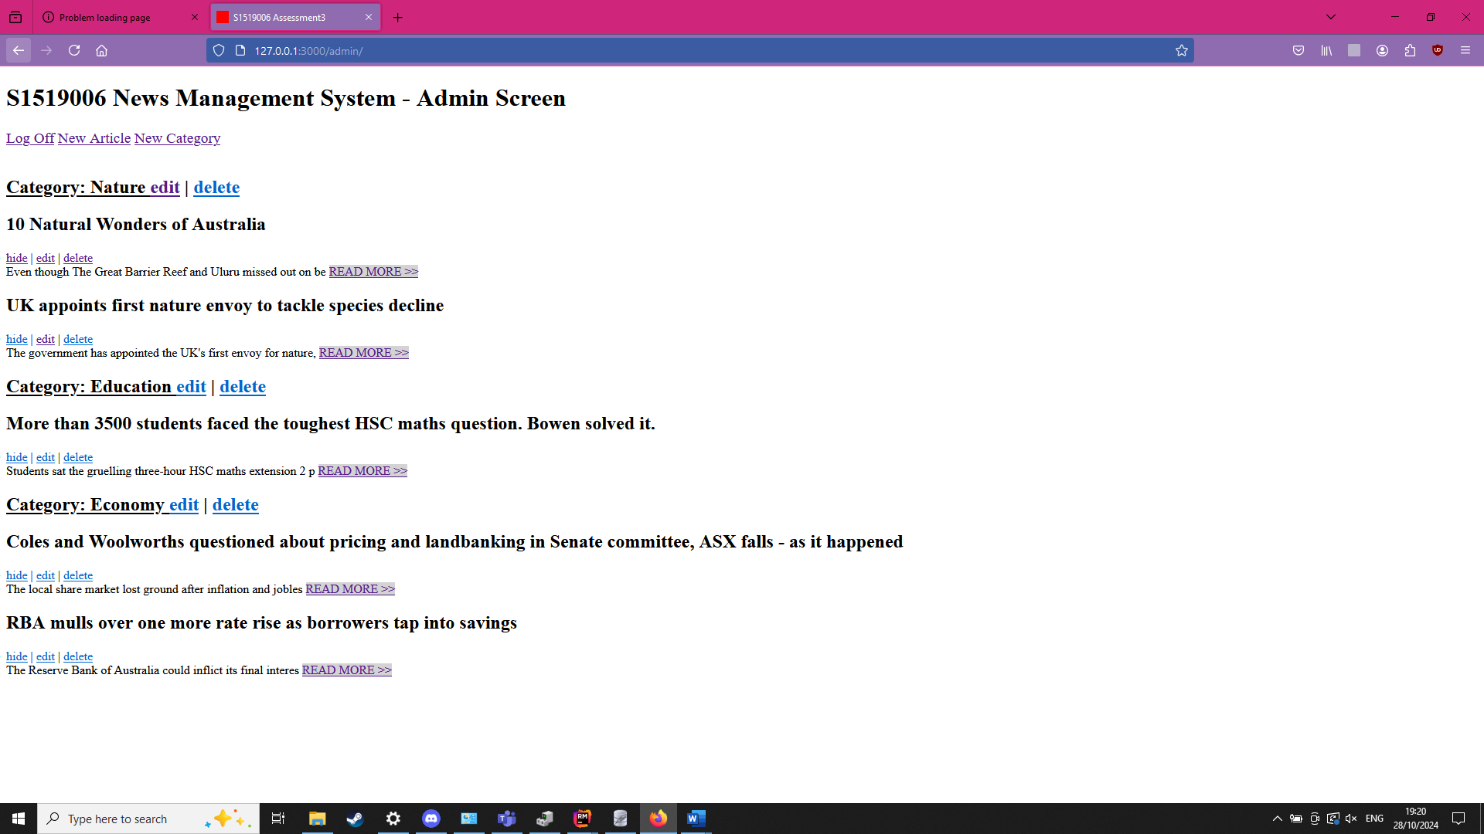

Create category
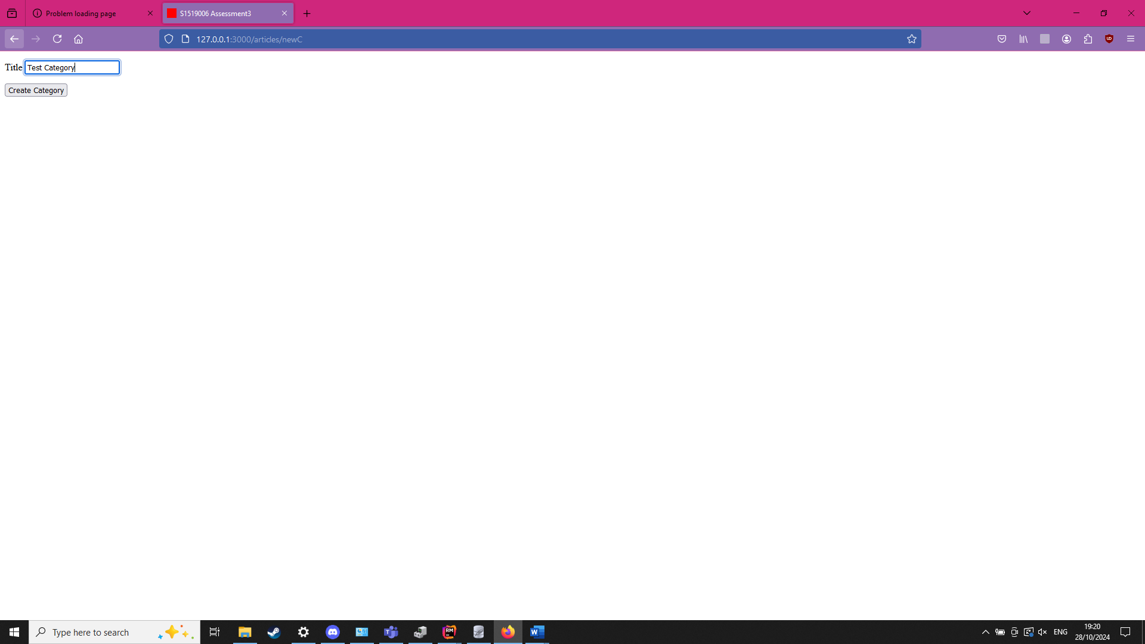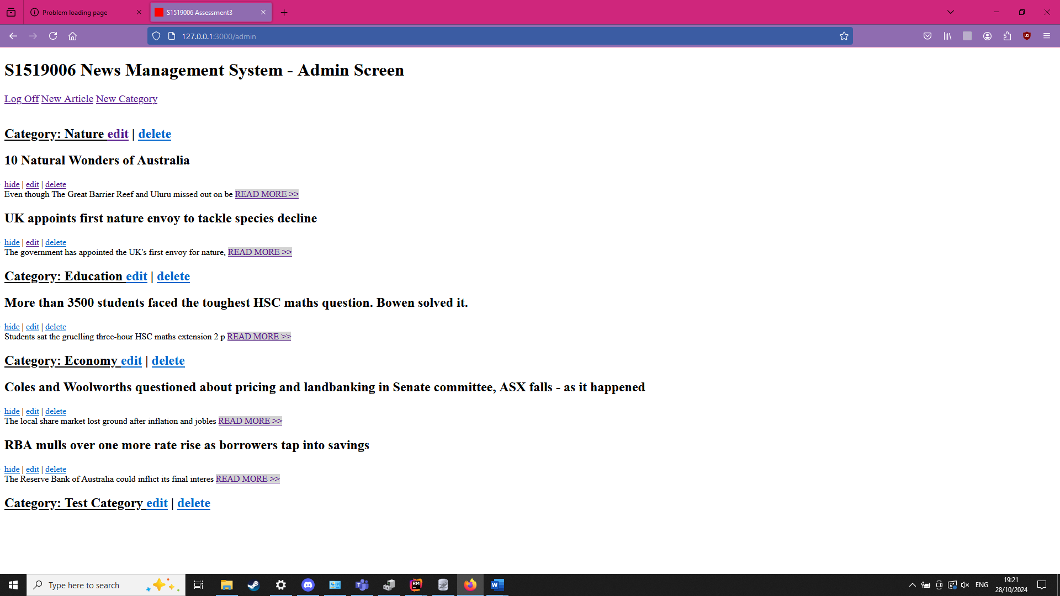

Create article
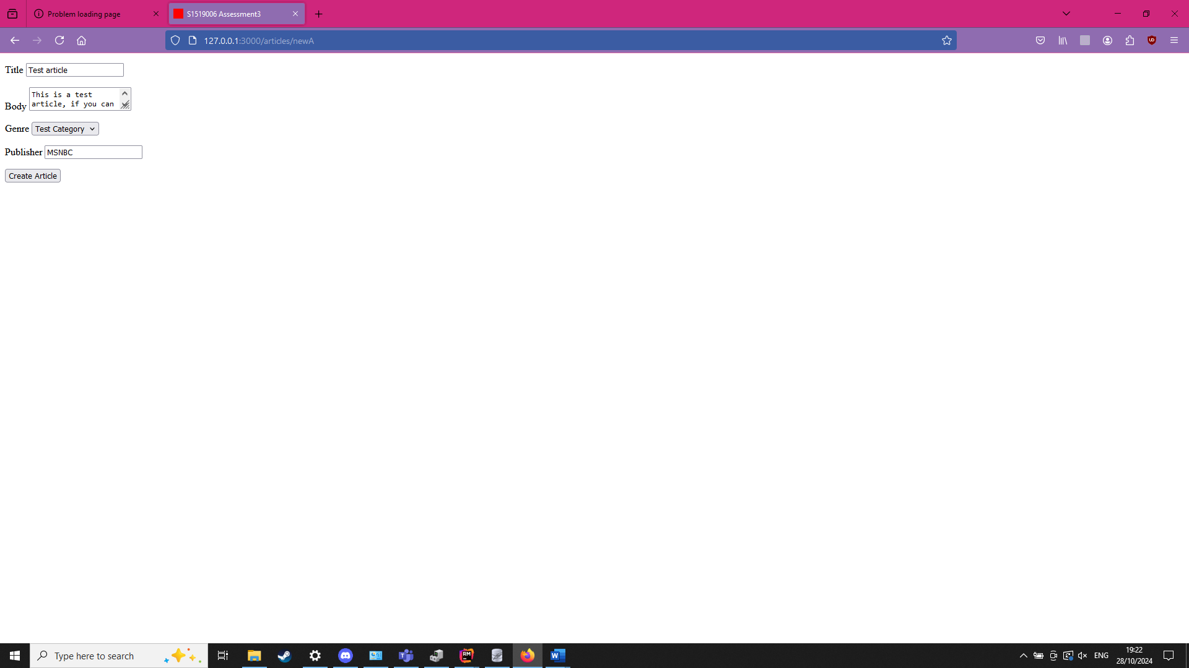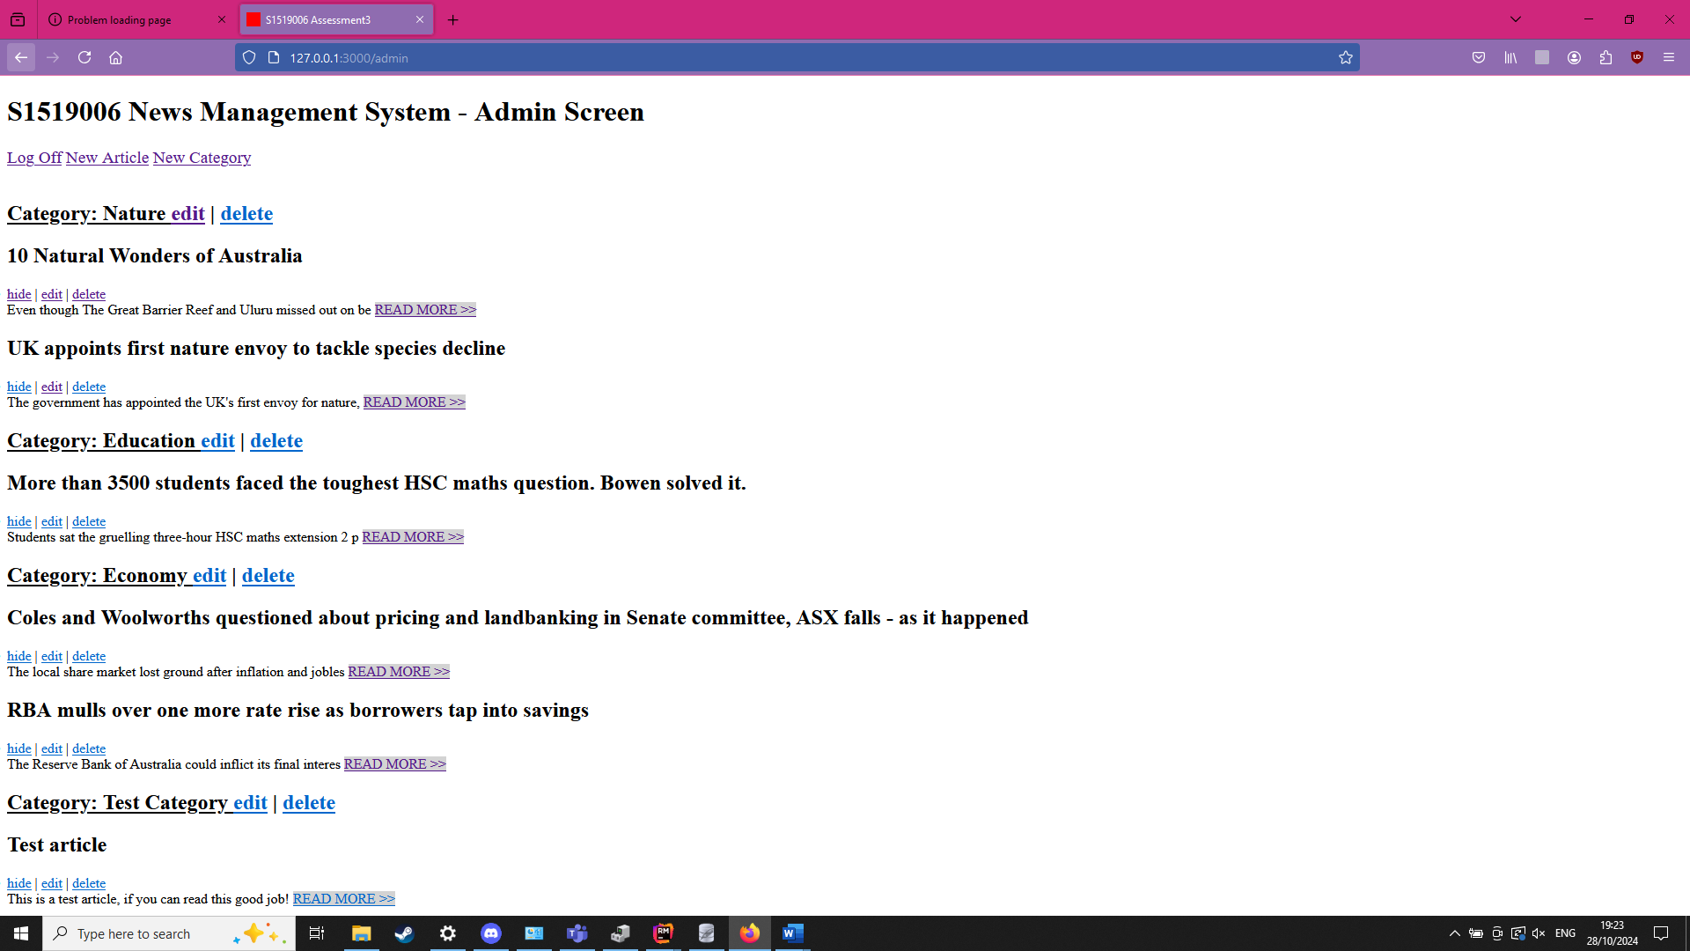

Edit article
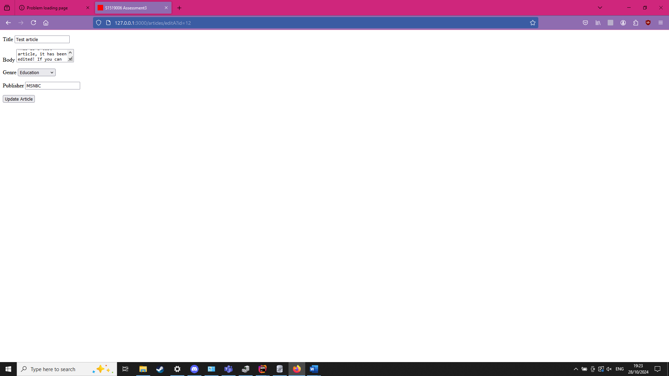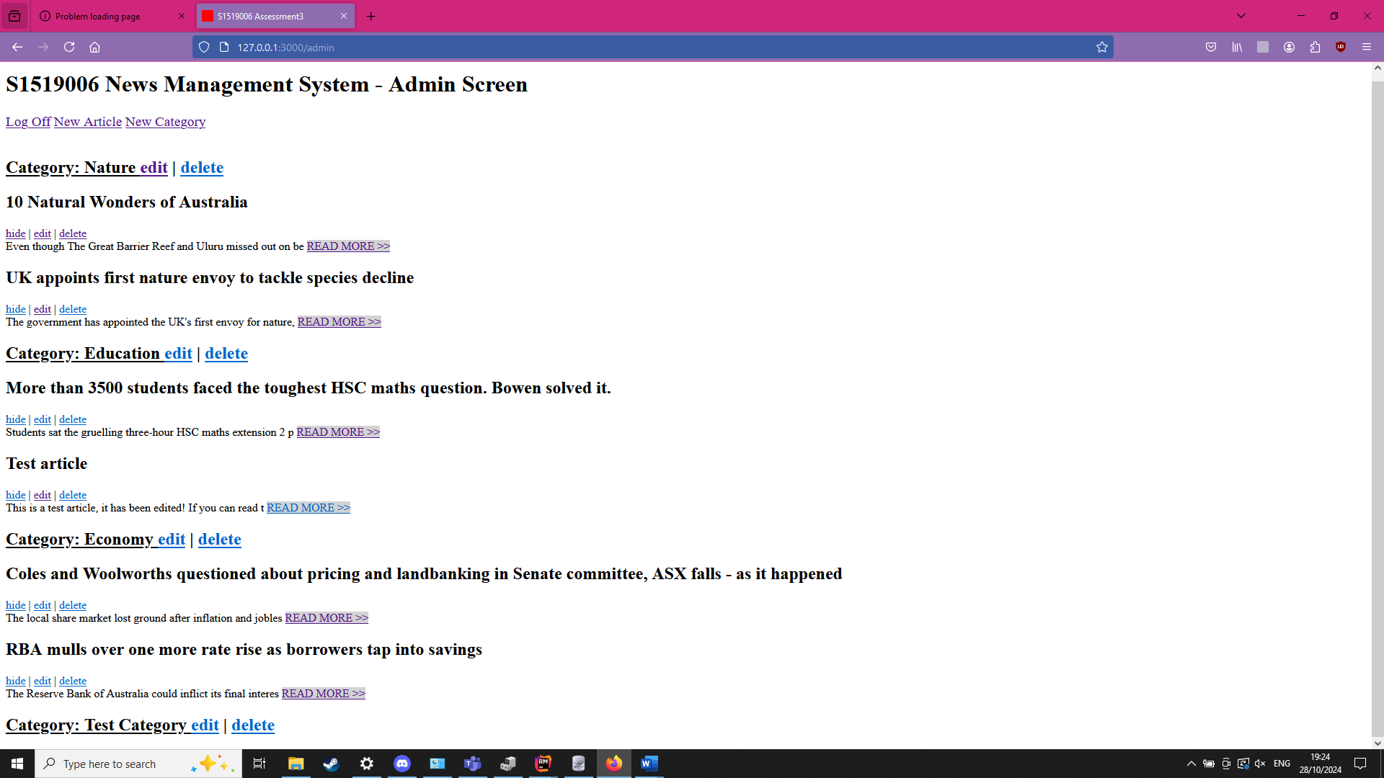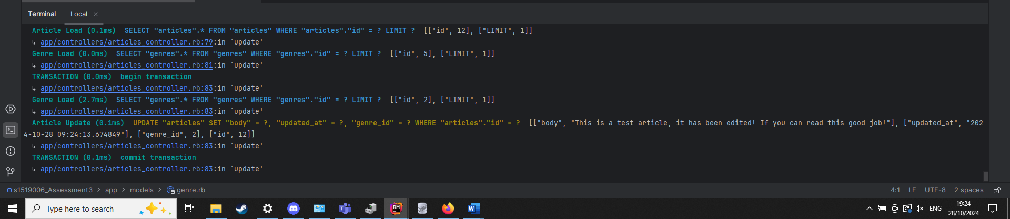

Edit category
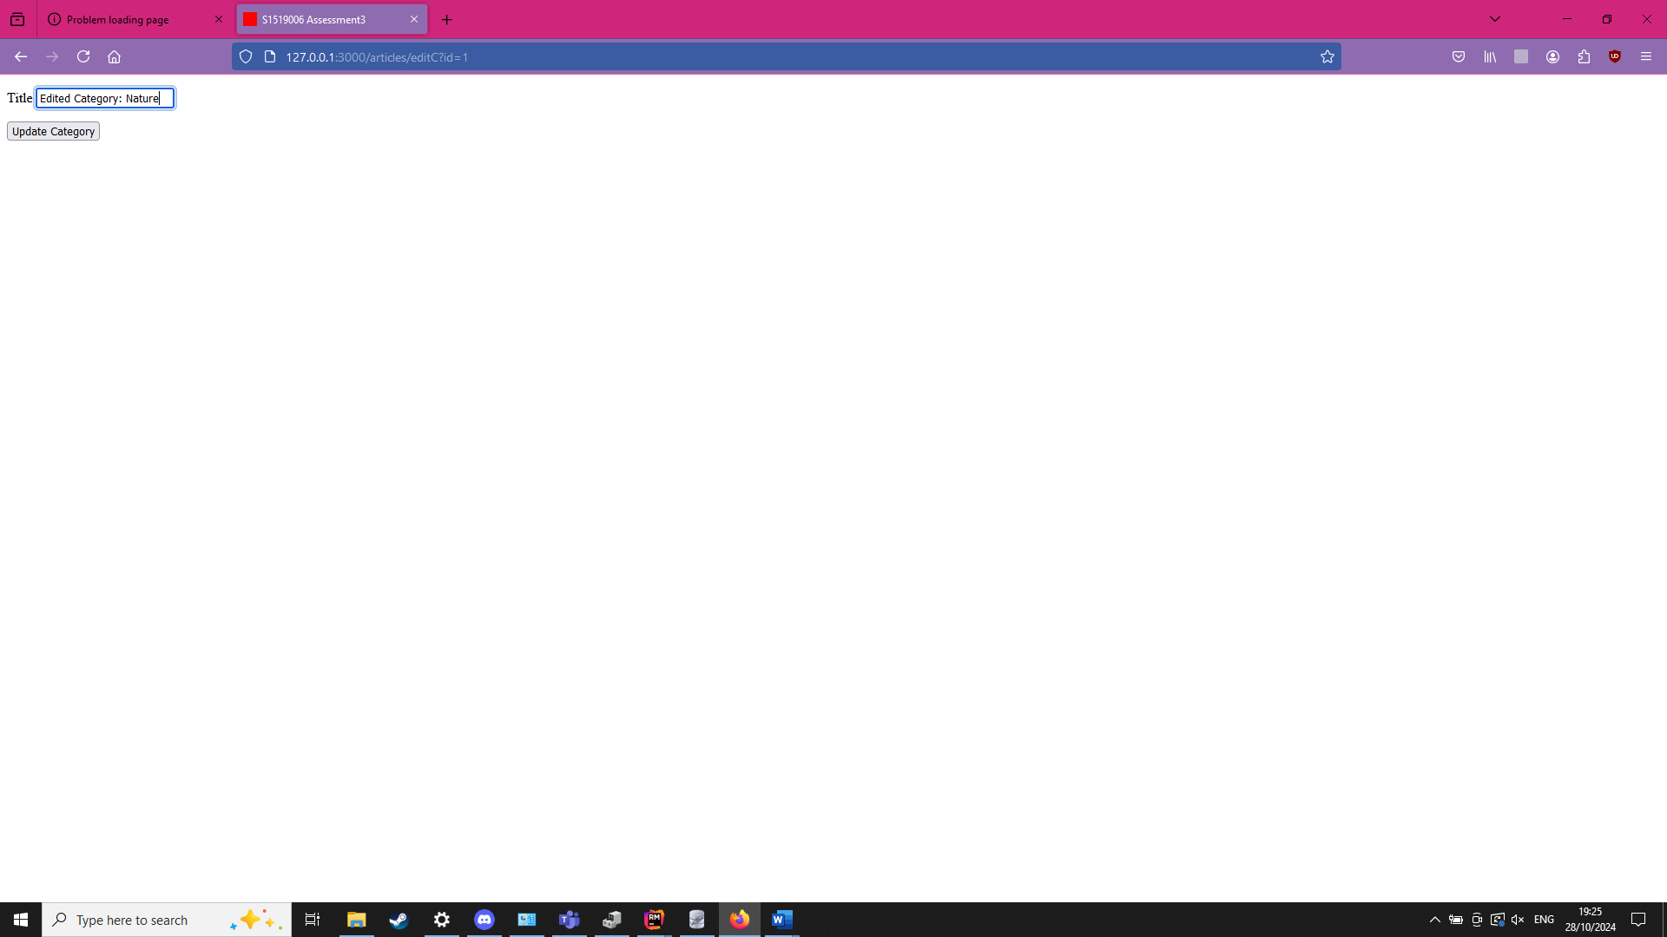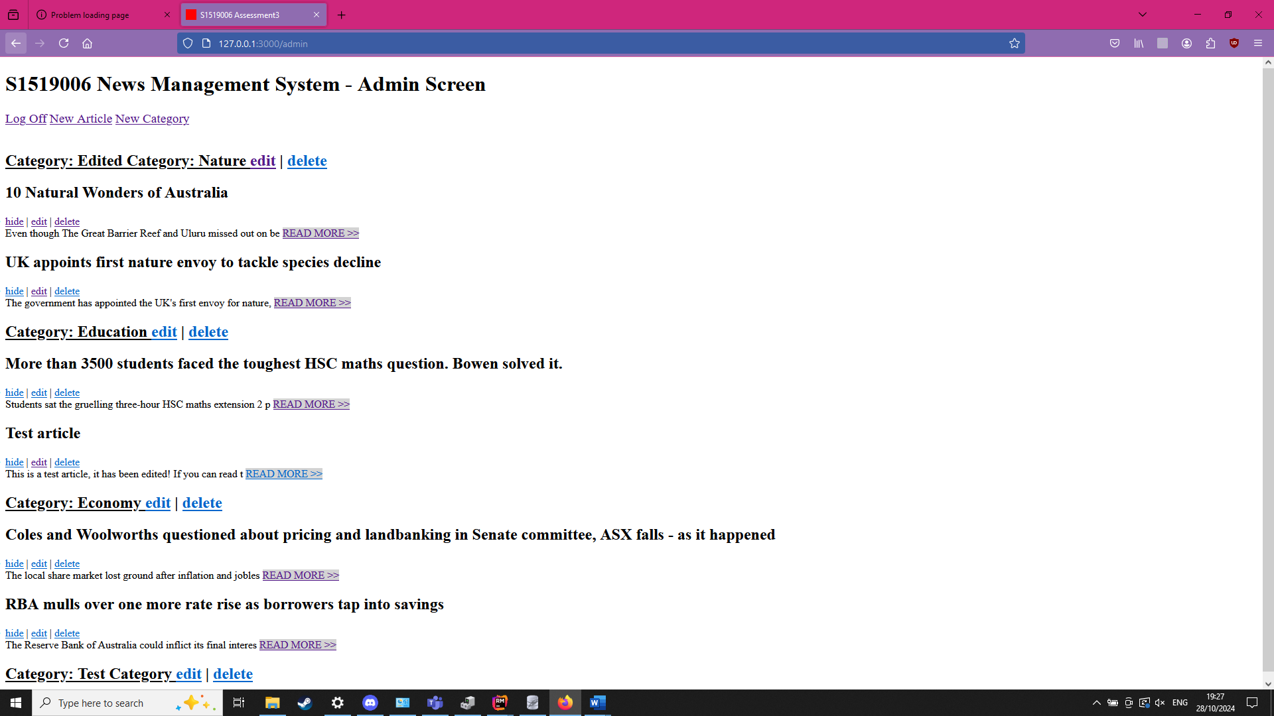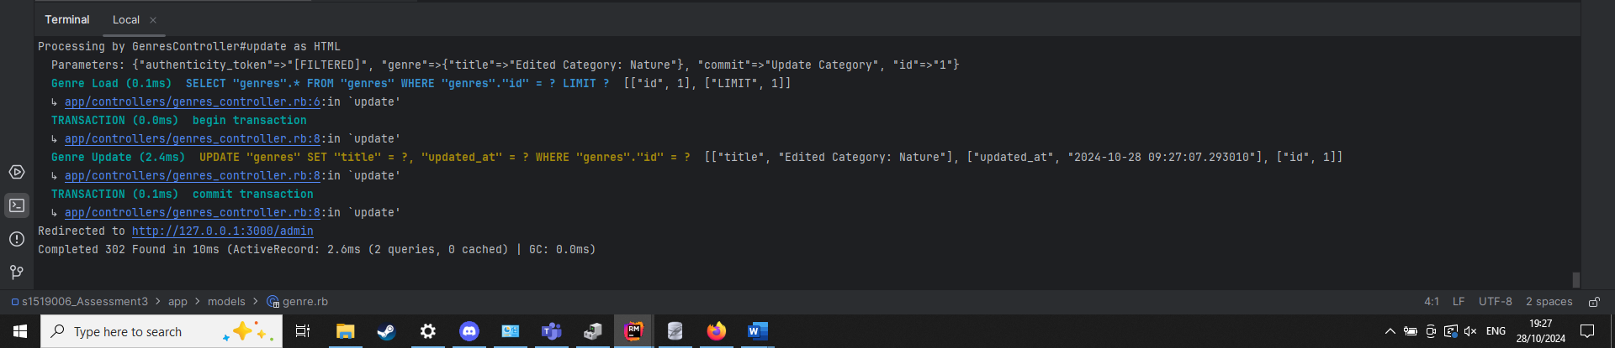

Delete article
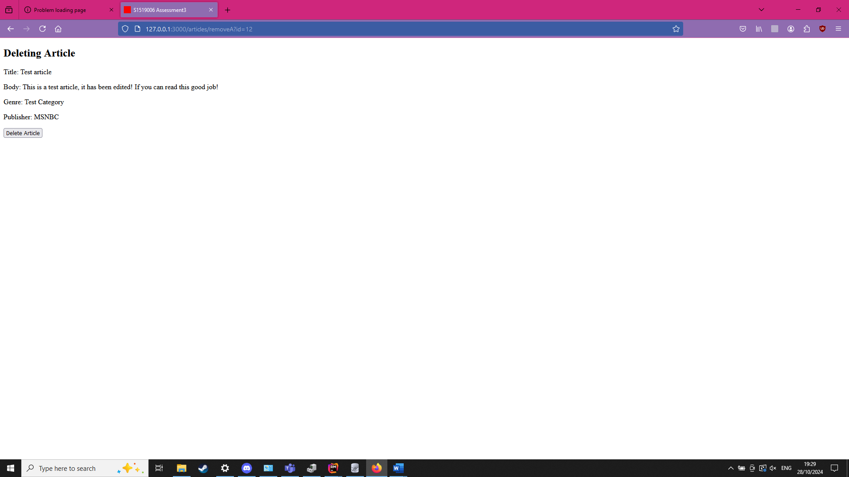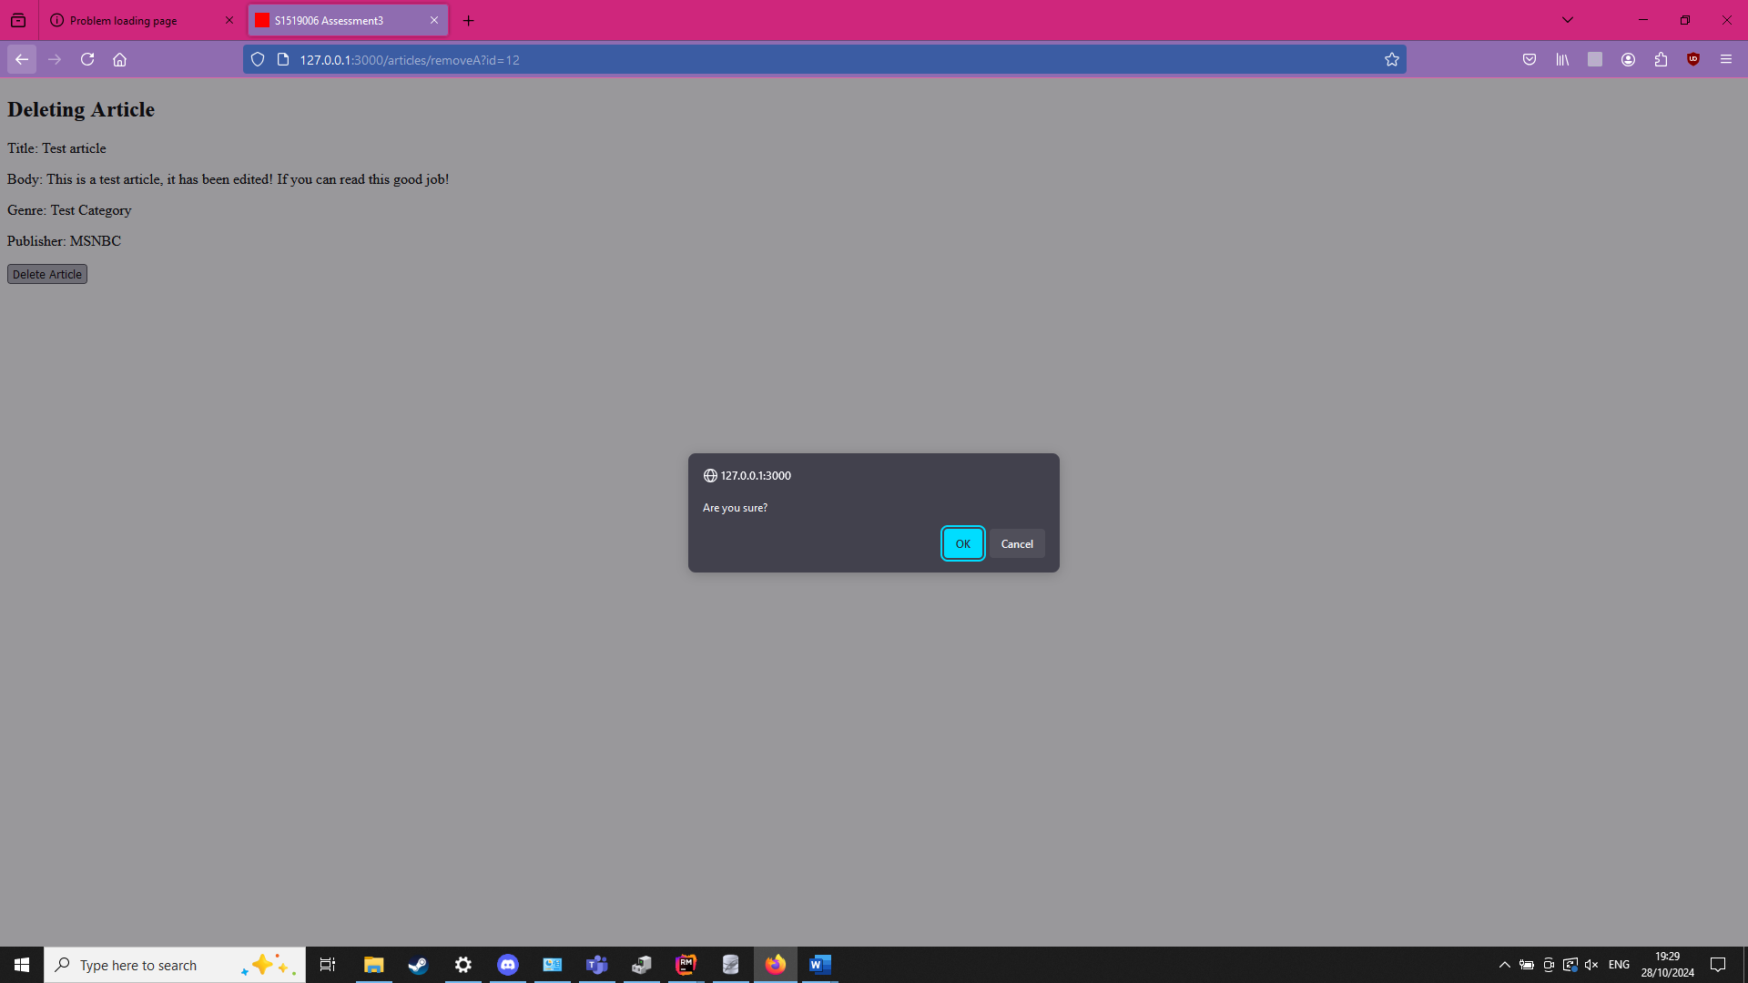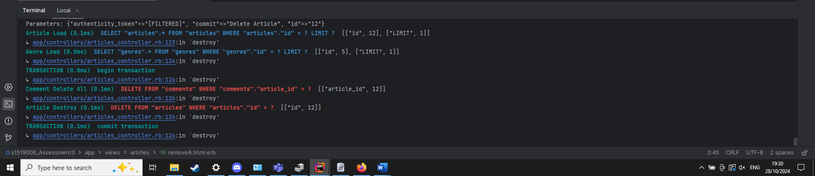

Delete category
